Unit 9 : INTRODUCTION TO OBJECT-ORIENTED PROGRAMMING

GETTING STARTED - Open a BlueJ application (BUT NOT the template)
You should now have the standard BlueJ screen
- Pull down the Project menu and select "Open project"
- It should show you the Desktop with the shapes folder, which you should now open

PRACTICAL EXERCISE
1. Introduction to Object-Oriented programming
Object- oriented programming is about creating objects and calling methods (aka functions, procedures) on these objects to get something to happen. BlueJ allows you to do this yourself by using its on-screen facilities. The rectangles in the middle of the screen represent “classes” (types) of objects. To find out how this world works, you will need to create some objects and then try doing something to them.
NOTE: we will eventually return to public static void main(String[] args)

2. Creating objects
- Right click (single) on Circle and select the option new Circle()
- BlueJ asks you for a name for your object – type in sun and press OK
- A red “object” icon appears on the Object Bench at the bottom of the BlueJ window
- Its label sun:Circle says it is an object called sun and it is a Circle type of object
- Right click on Circle again and create another object giving it a different name
- Create a third Circle object
- Notice that if you don’t give an object a name, BlueJ will give it one for you
You have now created three Circle objects.
- Create a Square and Triangle object (but NOT, for now, Canvas objects)

3. Objects have "behaviour"
Each object has "behaviour" - methods (aka procedures/functions) which you can use on it
- Right click on the sun object, and you will get a window showing the methods which are available to be used on it.
- Right click on another object to see what methods are available for it

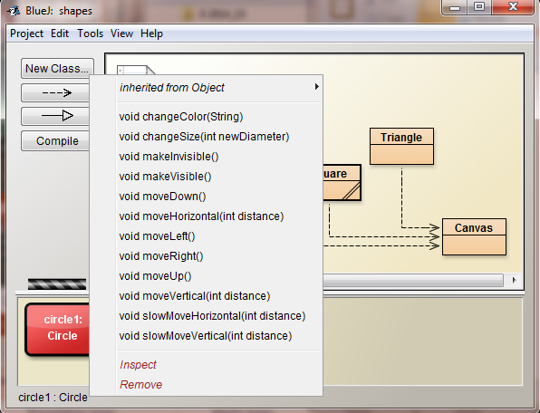

4. Operating on objects
In BlueJ, you can do something to an object by selecting a method from its list; you may be asked to supply additional data.
- Right click on the sun object, and from the window showing the methods select : moveRight() - nothing appears to happen !!!

5. Objects have "state"
Each object which you have created stores data in "fields" - the values in the fields are called the object's state.
- Double click on the sun object, and you will get its Object Inspector, showing its fields and their values
- Object Inspector windows tend to disappear, you can move them around and can always find them again on the bottom bar of your screen
- Open up object inspectors for the other object - notice similarities and differences

- Make sure that you can see the Object Inspector for the sun object; make a note of the values of the fields xPosition and yPosition
- Right click on the sun object and see what happens to these values when you select :
moveRight(), moveDown(), moveRight(), moveUp()

To help you see what you are actually doing, this project also has a display canvas on which you can see a visual representation of what is happening to your objects
Right click on the sun object and select : makeVisible()
- Now try a selection of the methods you tried earlier. Notice that not only do the values in the fields of the Object Inspector change, but so does the picture on the canvas.
- If the canvas disappears, just click on the coffee cup on the bottom of your screen.

Some methods require additional information
Select the method moveHorizontal(), you will be asked for a distance (in pixels)
Select the method changeColor(), you will be asked for a color. Type in one of the suggested colours; make sure they are in quotes. Note: try typing in other colours or names with capitals - you will see that they will not be accepted.
- Notice that you have to provide the correct "type" of information

- Challenge 1
Now that you have an idea of how to manipulate objects, you can try to draw this picture.
You task is not just to draw the picture, but to work out how to tell the computer to do it .
As you try things out, write down what you are doing.
The challenge is to produce the picture in the smallest number of instructions !!!!
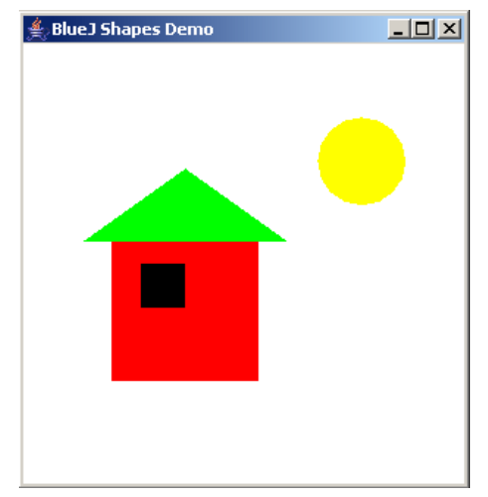
- There is NO DELETE in this project…..
- Since we want a clean canvas, close the project
and open it again
- To draw the picture you will need four object:
wall:Square, window:Square,
roof:Triangle, sun:Circle
- Create them on the Object Bench and for each
one call its makeVisible() method
- You will need to work out where to move them to,
what colours to change them to and how to
change their sizes. (wall - red, window - black,
roof - green, and sun - yellow)

7. Programming in Java
So far you have not really been doing any programming, but it is important for you to appreciate what can be done before we ask you to write code. You have been manipulating objects directly using the facilities provided by BlueJ. However, it is also possible to write Java code to draw the picture automatically.

Close the shapes project and then open the picture project
Create a Picture object on the Object Bench
Right click on the object and select its draw() method
- The picture should appear on the canvas.

Now we will look at the Java code which was written to produce this. Note: Java has quite a complicated syntax and we can only give you an idea of how it is written

Double click on the Picture class ; the rectangle in the middle of the BlueJ window to open the Editor and see the Java code. See how it matches your earlier instructions
- After comments and the class header, notice how the four objects have been declared.
- Now scroll through the code until you find the first line of the constructor which has the same name as the class: public Picture; everything between the { } belongs to this method and everything inside it is done when a Picture object is created
- Identify the Java code which creates an object e.g. wall = new Square();

- Scroll down to the next method public void draw(); everything between the { } belongs to this method and everything inside it is done when this method is called.
- Now look at how we call methods on objects e.g. wall.moveVertical(80);
- Notice how this code mimics what you were trying to do earlier.

- Scroll down and look at the other two methods available for the a Picture object
- Try to work out what they do from the code
- Call then on the Picture object you have already created on the Bench - did you get it right ?

This project is not ready yet to run outside BlueJ
- Look at the code in the Runner class - some of it should look familiar
- Notice: public static void main(String[] args)
- Picture house = new Picture(); // creates a Picture object
house.draw(); // calls its draw() method

8. Challenge 2 - add to the picture using Java instructions
- Add Java instructions to the Picture code to add a blue door and a chimney(Unfortunately, it will have to be a square door, because the authors of this project did not provide a Rectangle class)

- How can you make the sun set (go down) - find and call an appropriate method

Note: if you have a go at writing this code, you will notice that the Picture rectangle will acquire some diagonal lines. This means that before you can create a Picture object, you will have to get your code translated into machine code by clicking the Compile button.
Java is "case sensitive" - it is very fussy about capital and lower case letters

Notice that when you "compile" a class, the old objects disappear from the Bench and you have to create them again, if you want to try out your code.

9. Challenge 3 - get the computer to draw your own picture
- Design your own picture from squares, circles and triangle components e.g. a lorry
Try drawing using objects on the object bench first; note the methods you need to call and any values you need to give them e.g. what colour to change it to

- On the Project menu use Save as… to save the project as picture2

- Open the editor for the Picture class. Edit the code to:
- declare your components - give each component a name and specify its type
- in the constructor - create each component
- in the draw() method, write the methods calls
You will also need to "comment out" the setBlackAndWhite() and setColor() methods - just highlight the whole section and select Edit\Comment, this will put // at the start of each highlighted line and "grey out " the code

- When you think you have finished, compile your code - correct any errors identified by the compiler (if you are not sure what error messages mean, ask for help)

- Create a Picture object on the Bench and call the draw method. If you don't get the picture your want, go back and amend the code.

- Can you amend the setBlackAndWhite() and setColor() methods so that they work for your picture ?

10. Challenge 4 - write your own class (new code from old)
- Double click on the Circle class. There is a lot of complicated code here, but notice that all the fields have been declared at the top of the class and the each method that was available for an object has its own section of code.

- Look at the Square class code and notice both the similarities and the differences.

- From the Edit menu choose : New class.. and give it the name MyRectangle. Delete everything below the class header. From the Square class, copy everything below the class header and paste it into the MyRectangle class. Change the constructor name from Square to MyRectangle.

- Remember that a square is just a special rectangle where the sides are all the same length; for a rectangle we need both a length and a width. Amend the list of fields.
Now change any other code you think needs changing and test your solution

Useful websites & references
The BlueJ website is : http://www.bluej.org
The java website is : http://java.sun.com
The text book: "Objects First with Java - A practical introduction using BlueJ"
David J. Barnes & Michael Kolling, 4th Edition
Pearson Educational, 2008, ISBN 0-13-700562-8

